**TITLE:SMART WATER FOUNTAIN**

INTRODUCTION:

Automatic water flow: The water fountain ensures a consistent flow of water, which encourages pets to drink more and stay hydrated. Filtered water: Smart water fountains come with a filter that removes impurities and keeps the water clean and fresh.

**DESING AND INNOVATION:**

* Determine the primary purpose of your smart water fountain
* Set clear objectives for your design, such as reducing water waste, enhancing user convenience, and integrating technology.

**USER CENTRED DESIGN:**

* Understand your target audience and their needs. Consider the fountain's location, whether it's for a public space, office, or home.
* Create user personas to guide your design decisions.

**COPONENETS NEEDED**:

* PUMP
* PLASTIC TUBE
* FILTERS
* MOTORS
* WATER SENSORS

BLOCK DIAGRAM:

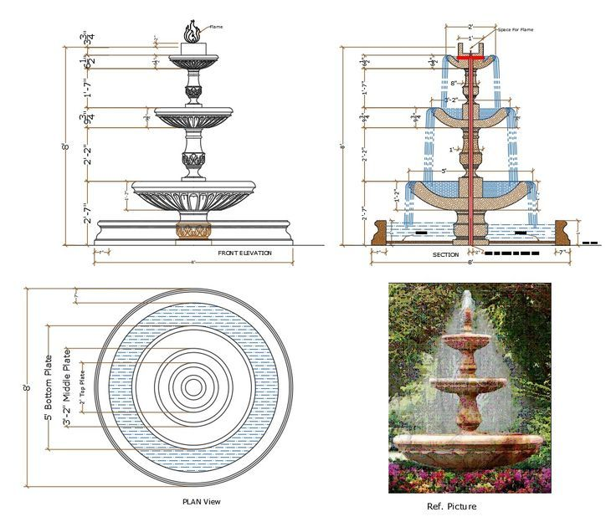

**USES:**

**PUMP:**

The supply pump must function when a low water level alert is raised. While no water supply is requested, the pump must prevent water flow between the main supply and the fountain. Requirement: The supply pump should have an operational condition around 3V, 200mA.

**FILTERS:**

Water quality is improved by the 3-stage filtration system, which removes hair and residual orders, and softens water to create better-tasting water. For better quality water, rinse the filter with water thoroughly before initial use. Replace the filter every 4 to 6 weeks to maintain water quality.

**MOTORS:**

Fountain pumps are typically centrifugal pumps, which move water using pressure from centrifugal force created by the movement of an impeller.

**WATER SENSORS:**

Fountain Pumps Selection Guide: Types, Features, Applications ...

Fountain pumps can also be either submersible or external. Submersible pumps have the pump motor hermetically sealed in the pump body, allowing the entire system to be submerged within the water reservoir or water source.These pumps are easier to install than external pumps, and typically are less expensive.

**BENEFITS:**

Automatic water flow: The water fountain ensures a consistent flow of water, which encourages pets to drink more and stay hydrated. Filtered water: Smart water fountains come with a filter that removes impurities and keeps the water clean and fresh.

**CONCLUSION:**

In conclusion, the design and innovation of a smart water fountain represents a harmonious fusion of technology, user-centricity, sustainability, and aesthetics. The smart water fountain is not merely a functional device for hydration but a holistic solution that caters to diverse user needs and contributes to a more connected and sustainable world. It is a reflection of progress in both design and engineering, aiming to provide a seamless and enhanced user experience.

With features such as water quality monitoring, touchless operation, personalized settings, and mobile app integration, smart water fountains offer convenience, safety, and customization**.** The incorporation of sustainability measures, such as energy-efficient components, water conservation features, and eco-friendly materials, underscores the commitment to minimizing environmental impact.